

Culture

Palestinian teens' Austria trip - a cultural respite from strife
Peter Haider
July 17, 2007

VIENNA -- Thirteen Palestinian teenagers from Bethlehem's Center for Conflict Resolution and Reconciliation recently had the chance to spend a memorable fortnight in Austria, a respite from the rigors of daily life in the occupied territories.
"We wanted to show that Palestine and its conflicts affect us. And we want to raise ... awareness for problems outside of our country," said one of the trip's main organizers, Bogdan Pammer, an 18-year-old student from the Austrian city of Steyr, in an interview with a local newspaper titled: "A break from the conflict in the Middle East."
The project, "Building Bridges to Bethlehem," was put together through the collaborative efforts of the groups Service for Peace‚ Universal Peace Federation, and Women's Federation, supported by the Palestinian community.
For the six young men and seven young women who visited Austria during the first two weeks of July, it was an altogether novel experience: green countryside, trees, meadows, lakes and, especially, the freedom to move in a country without walls, to roam the streets without fear, exploring wherever they felt like.
Twinned with Bethlehem, Steyr, an old industrial city in Upper Austria, was the young visitors' first destination, and they spent a week there as guests of local Austrian families. The Palestinian teens had the chance to hike in the mountains of the Kalkalpen national park, ride Segway electric scooters through city parks, visit the local BMW company and the World of Work museum, and even prepare a meal at a biological farm.
The young visitors participated in discussion evenings at a local Catholic club and a socialist youth group, and were invited to an official reception at the town hall. Former Steyr mayor and initiator of the twin city partnership, Hermann Leithenmayr, expressed his gratitude during a cultural event at a local high school: "Such a project brings new life to our partnership with Bethlehem."
At the beginning of their second week in Austria, the Bethlehem youngsters traveled on to Vienna.
There, 150 people gathered for an inter-religious charity event in honor of the project, which included a report on the continuing activities of the Middle East Peace Initiative, short statements by the young guests, themselves, and a Palestinian dance performance. The Palestine Mission ambassador, Zuheir Elwazer, also talked about recent developments in the occupied territories.
After a day of sightseeing in the Austrian capital, the Bethlehem group moved to a youth hostel in Seebenstein, near Vienna. For two days, they discussed peace, conflict, and reconciliation with Austrian youth, supervised by experts.
One day was set aside to visit the United Nations and Vienna parliament. The Palestinian youth listened to the history of the development of democracy from the time of the Austro-Hungarian Empire, with eight nationalities represented and 11 languages spoken in the assembly, to the rebuilding of modern democracy after the destruction of parts of the parliament building during World War II.
Also among the highlights of their time in Austria's capital was the group's invitation by a Vienna district mayor to the top of the 150-meter (490-foot) Danube Tower. There, they were able to take in a breathtaking view of the metropolis, despite gusts of powerful wind.
On the last day of their trip, the Palestinian teens headed to Lake Neusiedl that borders Hungary, with a side visit to the Parndorf Designer Outlet. They were welcomed by the local mayor and invited to lunch by the manager. After a brief time shopping, the group went on to enjoy a tour of the lake.
The day ended with an evening of Palestinian food, a thought-provoking pantomime about daily life under occupation, and Arabic dancing and music - the perfect conclusion to a trip that will remain in the memories of all who took part.
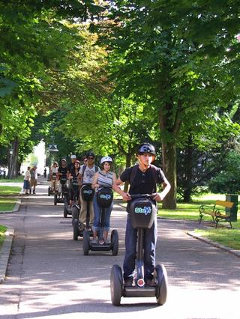
FREE-WHEELING: Palestinian teens on a two-week July cultural exchange trip to Austria, ride Segway electric scooters through the Austrian city of Steyr, twinned with the occupied West Bank town of Bethlehem.

http://www.metimes.com/

